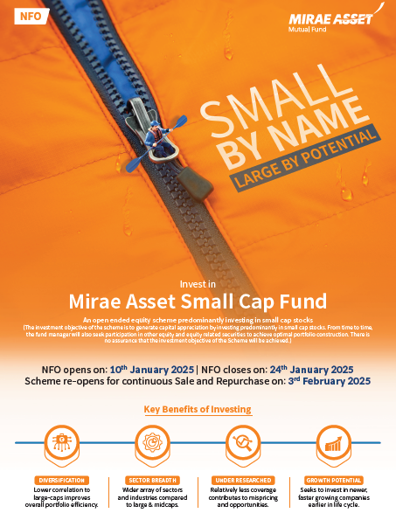

Mirae Asset Small Cap fund – NFO
NFO Period: 10/01/2025 To 24/01/2025
Brokerage Structure for Mirae Asset Small Cap fund - NFO for <ARN NAME> (ARN NO)

(For Load Structure please refer to the latest SID/SAI on our website www.miraeassetmf.co.in)

Amount | B30 Special Incentive | 1st Year | 2nd Year | 3rd Year | 4th Year & Onwards
Default ( =< 2 Lacs ) | - | 1.00% | 1.00% | 1.00% | 1.00%
2 Lacs – < 5 Lacs | - | 1.10% | 1.10% | 1.10% | 1.00%
5Lacs – < 10 Lacs | - | 1.20% | 1.20% | 1.20% | 1.10%
10Lacs – < 25 Lacs | - | 1.30% | 1.30% | 1.30% | 1.20%
25Lacs – < 50 Lacs | - | 1.40% | 1.40% | 1.40% | 1.30%
50Lacs – < 75Lacs | - | 1.50% | 1.50% | 1.50% | 1.40%
75Lacs – < 1CR | - | 1.60% | 1.60% | 1.60% | 1.50%
> = 1CR | - | 1.70% | 1.70% | 1.70% | 1.60%

*Upfront Fee: Nil
Terms and Conditions:
- Annualized commission including Trail Commission will be computed on monthly average AUM and paid on a monthly basis.
- GST on brokerage commission is payable by distributor as service provider. We pay commission on gross and inclusive of all statutory levies including GST (as amended from time to time)
- For invoice generation and reporting process, please visit https://mfs.kfintech.com/mfs/distributor/distributor_Login.aspx
- For switches from any Equity/Hybrid (excluding Arbitrage Fund)/FOFs scheme to NFO Small Cap Fund brokerage will be paid as base brokerage (0.75%)
- Brokerage slab will be applicable on actual/Net investment amount. (ie. Investment amount after deducting stamp duty OR any other charges levied if any)
- The AMC reserves the right to change the entire/part brokerage structure at any time, without prior notice. The above commission structure supersedes all the previous commission structure(s) which were communicated prior to this date for this period if any. For latest load structure and Scheme Information Document(s) of respective schemes, Statement of Additional Information and Addendums issued from time to time, please refer to our website www.miraeassetmf.co.in .
- In accordance with the clause 4(d) of SEBI Circular No. SEBI/ IMD/ CIR No. 4/168230/09 dated June 30, 2009, the distributors shall disclose all commissions (in the form of trail commission or any other mode) payable to them for the different competing Schemes of various Mutual Funds from amongst which the Scheme is being recommended to the investor. Distributors are advised to ensure compliance of the same.
- No pass back, either directly or indirectly, shall be given by Distributors to the investors
- The distributor shall not offer any indicative portfolio and indicative yield of any scheme.

THE DISTRIBUTOR AGREES THAT SOURCING OF FUNDS FOR MIRAE ASSET MUTUAL FUND SCHEME(S) AFTER RECEIPT OF THIS BROKERAGE STRUCTURE INCLUDING THE ABOVE REFERRED TERMS AND CONDITIONS SHALL BE CONSTRUED AS AN AGREEMENT OF HIS/HER/ITS ACCEPTANCE TO THE TERMS AND CONDITIONS.
Mutual Fund investments are subject to market risks, read all scheme related documents carefully

